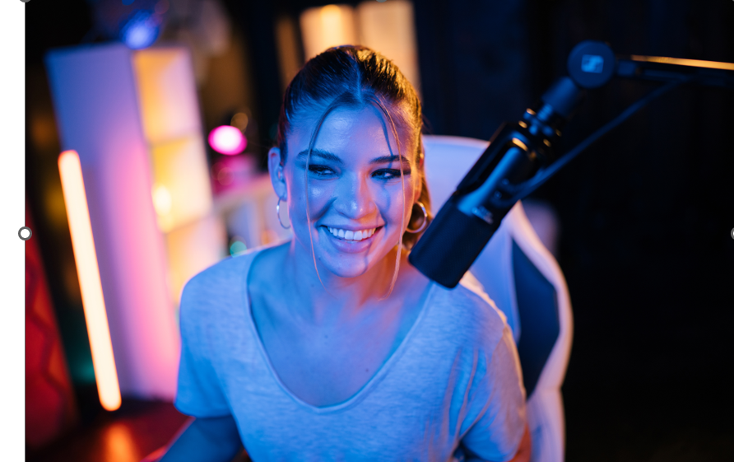**Sennheiser to showcase its content creation tools at VidCon Anaheim 2023**

**The audio specialist will demonstrate its best-in-class solutions for streamers, creators and podcasters like the EW-DP camera-mounted wireless system, MKE series microphones, the Profile Microphone and more**

***Anaheim, CA, June 20, 2023* — Sennheiser [booth #MR3] will be showcasing its latest solutions for content creators during VidCon Anaheim 2023, to be held at the Anaheim Convention Center from June 21 through June 24. Since 2010, VidCon has been focused on the digital culture, connecting a vast community of content creators, platform innovators and fans all in one place. During the four-day event, Sennheiser will be on-site demonstrating how audio plays a critical role in delivering a story for creators, streamers and podcasters.**

|  |  |
| --- | --- |
|  | EW- DP, Sennheiser’s 5th generation of Evolution Wireless systems for filmmaking and video applications will be presented at the show. |

Sennheiser will have audio content creation tools and experts on hand during VidCon, presenting a great opportunity for both knowledge sharing and an in-depth overview of the most compelling audio solutions available for content creation. During the exhibition, Sennheiser will feature four main areas: EW-DP interactive featuring camera mount solutions and headphones; a 'Let's Talk Audio' area with iPad stations in which attendees can experience educational audio / video shorts; a professional audio-for-video table featuring Sennheiser's industry standard shotgun microphones, mobile kits and wireless lavalier solutions; and a podcaster / content creator desk which will feature a streaming set-up in combination with Sennheiser's new Profile USB podcasting microphone.

|  |  |
| --- | --- |
|  | The Profile USB microphone for streaming, podcasting, and gaming applications is available with a table stand or streaming set with a boom arm, making it a great solution for streamers, podcasters, and creators. |

Sennheiser will be showcasing tools for content creators including, but not limited to:

* **Profile USB Microphone**  
  A USB-C microphone, with a cardioid condenser capsule and integrated features designed for enhanced Podcasting and Streaming applications. With plug-and-play simplicity, the Profile delivers a natural, warm sound that accentuates the body and presence of the human voice right out of the box.
* **MKE 200 Mobile Kit**   
  Designed for vloggers and content creators on the move, the MKE 200 Mobile Kit includes Sennheiser’s MKE 200 directional on-camera microphone and Smartphone Clamp, as well as the Manfrotto PIXI Mini Tripod. The MKE 200 features a built-in windscreen and shock mount to help reduce handling noise while the Smartphone Clamp allows for both portrait and landscape orientation.
* **XSW-D Lavalier Set**  
  A 'one-touch' wireless audio set that utilizes a digital transmission to seamlessly link audio sources. Equipped with an ME2-II lavalier microphone, this easy-to-use solution makes wireless presentations simpler than ever while maintaining a reliable connection.
* **Evolution Wireless Digital: EW-DP camera-mounted solutions**  
  EW-DP is a fully digital UHF wireless microphone system with a new portable design and unmatched audio quality for content creators, filmmakers, and broadcasters, The EW-DP ME 4 SET includes a cardioid clip-on microphone for noisier environments, while the EW-DP 835 SET contains a handheld transmitter with cardioid MMD 835 dynamic microphone head.

Sennheiser will support content creators attending VidCon with a gear loan program for equipment to be used during the convention. Loaner products will be made available on a first-come, first-served basis, and for a very limited time. Interested parties can register here: <https://ui0c69qh067.typeform.com/VidConGearLoan>.

To explore Sennheiser's audio-for-video content creation tools, please visit the Sennheiser website at (https://en-us.sennheiser.com/high-quality-audio-for-video). We look forward to welcoming you at VidCon!

(Ends)

**About the Sennheiser Group**

Building the future of audio and creating unique sound experiences for our customers - this is the aspiration that unites the employees of the Sennheiser Group worldwide. The independent family-owned company Sennheiser was founded in 1945. Today, it is managed in the third generation by Dr. Andreas Sennheiser and Daniel Sennheiser, and is one of the leading manufacturers in the field of professional audio technology. Within the Sennheiser Group are Georg Neumann GmbH (Berlin, Germany), manufacturer of studio-grade audio equipment; Dear Reality GmbH (Düsseldorf, Germany), known for its binaural, Ambisonics, and multichannel encoders with realistic room virtualization; and Merging Technologies SA (Puidoux, Switzerland), specialist in high-resolution digital audio recording systems.

[sennheiser.com](https://protect-eu.mimecast.com/s/lUszCgxgJHAZzmKWSo3cGI?domain=sennheiser.com) | [neumann.com](https://protect-eu.mimecast.com/s/hW3dCm2oZUjNQA8YSDwLrJ?domain=neumann.com) | [dear-reality.com](https://www.dear-reality.com/) | [merging.com](https://www.merging.com/)

**Local Press Contacts**

Daniella Kohan Jeff Touzeau

daniella.kohan@sennheiser.com jeff@hummingbirdmedia.com

+1 (860) 227-2235 + 1 (914) 602-2913